Time limitations for talks:

10 minutes / 3 minutes Q&A

Creating an mp4 of your Powerpoint using Zoom. (If you choose, you may also use the new functions of Powerpoint directly to record your presentation and save as an mp4. This allows you to record slides one at a time, adjust the size of your speaker window and position it anywhere you want on each slide)

You will need a computer with a webcam and a microphone and any version of Zoom (the instructions may vary slightly if you are using a Mac or Windows, or if you are using Zoom in a browser or on the app. Whichever it is, the commands and buttons should be the same, however you may have to search your screen to find them.

Download Zoom. https://zoom.us/ Create an account if you don’t already have one. Once you log in, download ‘Zoom Client for Meetings’. Although you can access Zoom online in your web browser, you will need to download Zoom in order to record your talk. You want to download “Zoom Client for Meetings”

Once the installer downloads, double-click it to run it and log in.

Prepare for recording

When you design your Powerpoint presentation, make sure to leave a small square empty at the top right hand corner of your screen. This square is where the video of you talking will appear during the recording. It will cover up any important figures so just leave it blank on ALL slides in the presentation. You can adjust the size of the speaker window before starting to record, but it will always appear in the upper right corner, even if you move it to another part before recording.

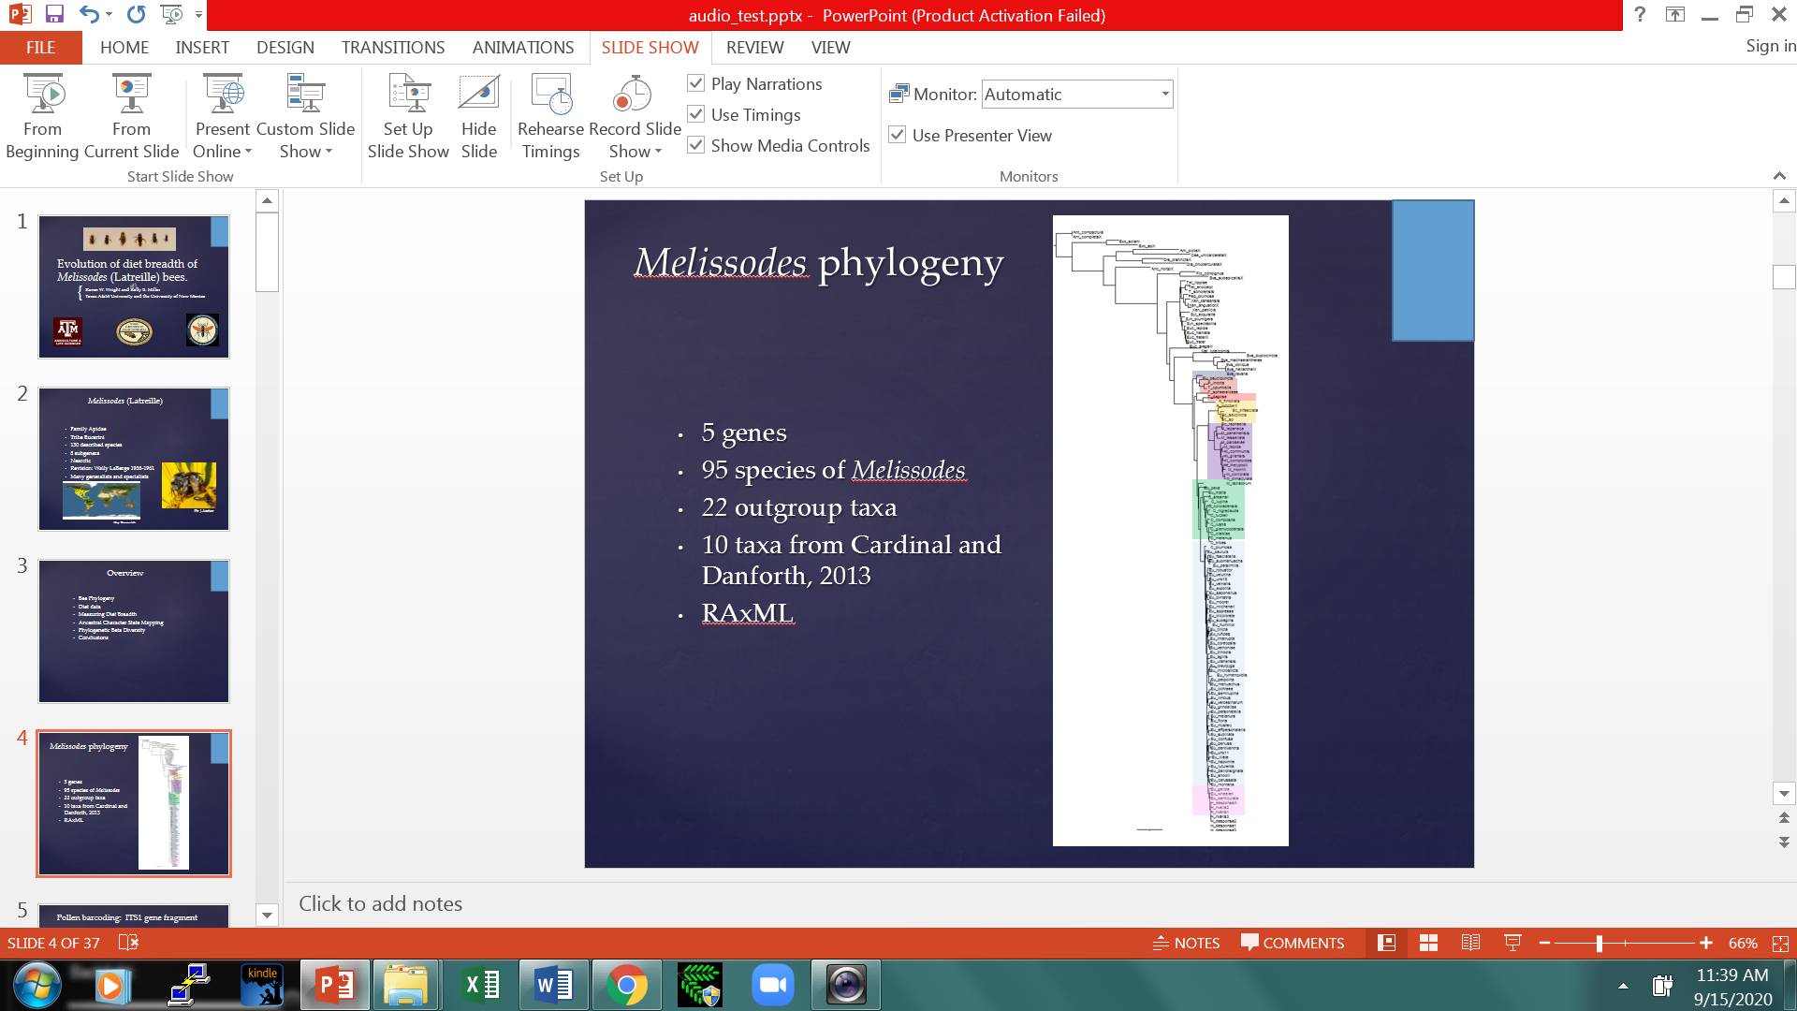

Open your Powerpoint session on your computer before you begin a Zoom session, so they are easy to find as you go. It is highly recommended that you only have the windows open that you will be using and close all others. Make sure your screen saver is acceptable for public viewing.

Open the Zoom App on your computer.

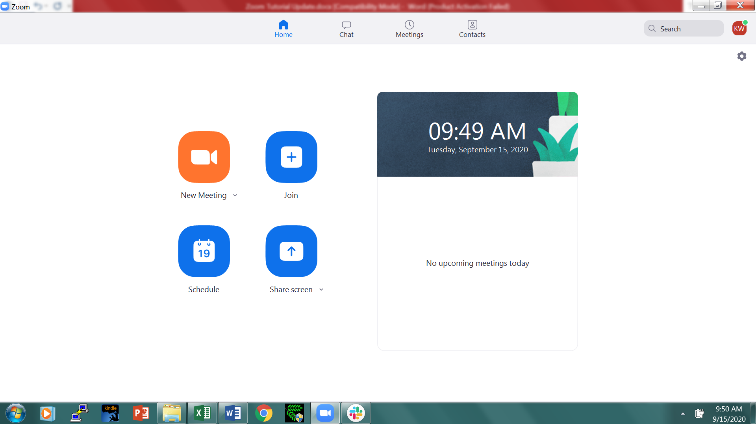

Click ‘New Meeting’
Click ‘Test Speaker and Microphone’ and follow instructions.
Click ‘Join with Computer Audio’
In another window, open Powerpoint and open your slide show, make sure the first slide is the one showing, but don’t start the slide show.

Back in Zoom, click ‘share screen’. It will then show you all the windows open on your computer. Choose your Powerpoint presentation by clicking on it.

In Zoom on the shared screen, start your slide show. Look closely at the background of your video. Make sure that it is acceptable for public viewing, check the light levels and adjust so your face is clearly visible without bright light washing out the picture or dark shadow.

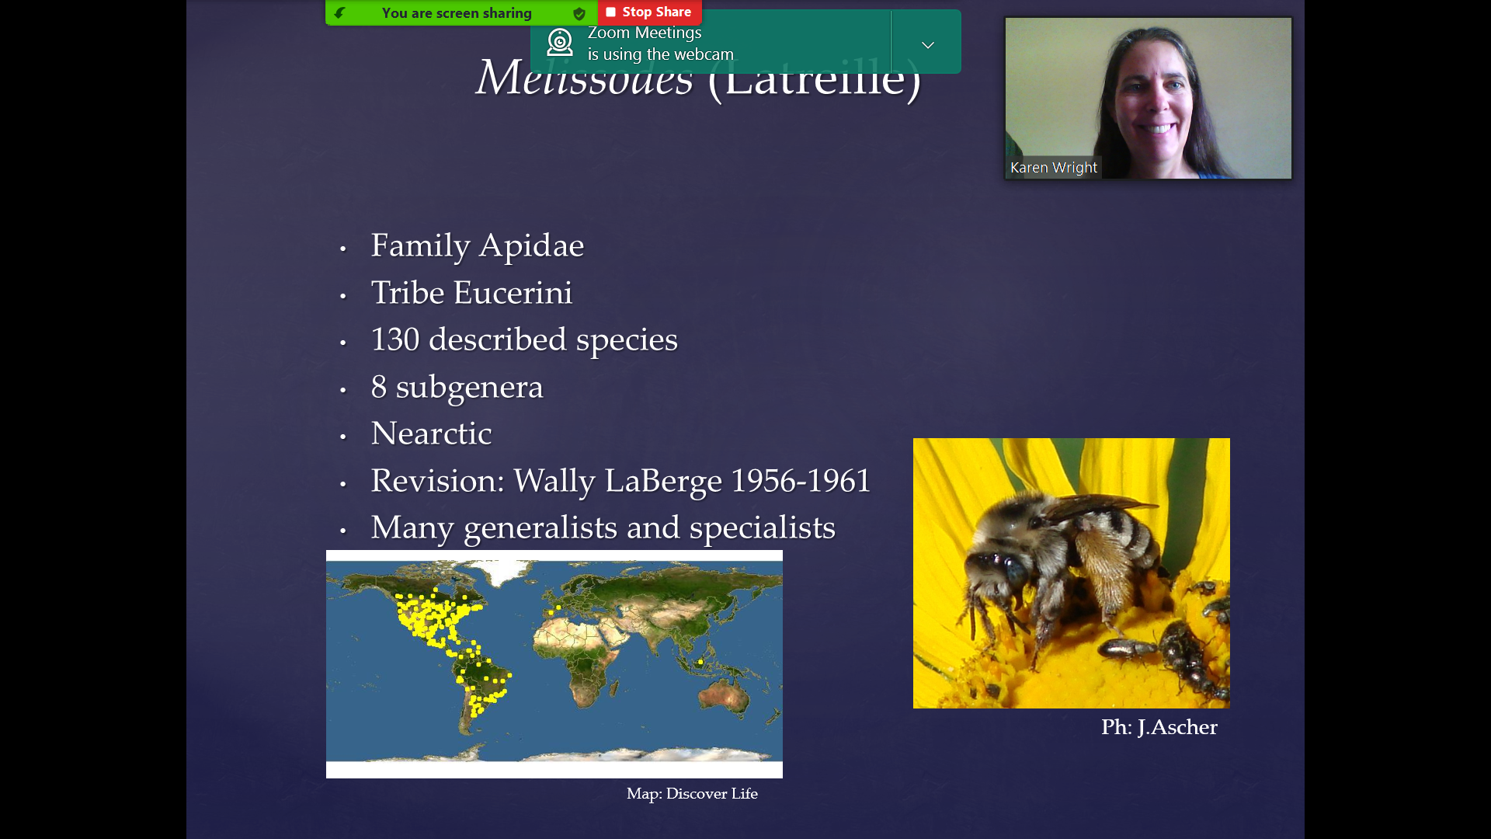

On your screen, there is a bar that says ‘You are screen sharing’. If you run your cursor over this green bar, a horizontal drop down menu will appear. On the far right you will see “More”. If you run your cursor over this, a vertical drop down menu will appear. When you are ready, click on ‘Record on this computer’. Give your talk in the most natural way that you can, try to look at the camera while you are talking. Talk in a normal conversational manner. When you are finished, remember to thank people and then pass your cursor over the green bar again, move to More, when the dropdown list appears, click on ‘Stop Recording’. End the meeting.

Once you end the meeting, a popup box will appear and the recording will be automatically converted to an mp4 and saved to your Documents folder on your computer in a Zoom folder labeled with the time and date of the recording.

Go to your Zoom folder, open your mp4 file and watch your video. The video box will appear in a different place on the mp4, still in the top right corner but justified to the top-right. When you are ready to make your recording, make a test run to check the placement of your video, the sound quality and lighting of the video. If you are unsatisfied with the results, delete the entire dated folder and try again. If you are satisfied with your talk, please rename it as follows…

LepSoc2021: ‘Yourlastname.mp4’

Please submit your abstract by July 16, 2021 to: meeting@lepsoc.org. Please indicate on your submission if you are participating in the student paper competition.

Once we receive your abstract, we will send a link to a Google Drive folder where you can submit your mp4 video.

Complete your registration for the meeting by visiting the society website at https://www.lepsoc.org/

